实验（11）—— STL

学生姓名：黄伟杰 专业班级：计算机211
课程名称：面向对象程序设计 实验类型：综合

一 实验目的
练习C++STL。

二 实验环境
PC机 + Windows 10操作系统 + CodeBlocks 集成开发环境

三 实验内容
1 使用deque，存储用户输入的N个小数，再依次打印并输出这些小数的均值
#include <iostream>
#include <deque>
using namespace std;
int main() {
int n1 = 5;
double averVal1 = 0;
deque<double> idq1;
for (int i = 1; i <= n1; i ++) {
double x = i * 1.1;
idq1.push_back(x);
averVal1 += x;
}
averVal1 /= n1;
for (deque<double>::iterator it = idq1.begin(); it != idq1.end(); ++ it) cout << *it << " ";
cout << "Average = " << averVal1 << '\n';
int n2 = 10;
double averVal2 = 0;
deque<double> idq2;
for (int i = 1; i <= n2; i ++) {
double x = i * 1.5;
idq2.push_back(x);
averVal2 += x;
}
averVal2 /= n2;
for (deque<double>::iterator it = idq2.begin(); it != idq2.end(); ++ it) cout << *it << " ";
cout << "Average = " << averVal2 << '\n';
return 0;
}
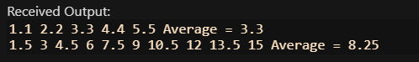
2 使用stack，逆序打印输出'a'-'z'
#include <iostream>
#include <stack>
using namespace std;
int main() {
stack<char> is;
for (char i = 'a'; i <= 'z'; i ++) is.push(i);
while (is.size()) {
cout << is.top() << " ";
is.pop();
}
return 0;
}
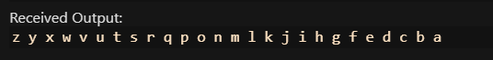
3 放若干书本对象进queue，并顺序输出这些书本的书名、价格
#include <iostream>
#include <string>
#include <queue>
using namespace std;
class Stu {
public:
string name;
int price;
Stu(string _name, int _price) : name(_name), price(_price) {}
};
int main() {
Stu t1_1("Book1_1", 10), t1_2("Book1_2", 20), t1_3("Book1_3", 30);
queue<Stu> t1;
t1.push(t1_1);
t1.push(t1_2);
t1.push(t1_3);
while (t1.size()) {
cout << t1.front().name << " " << t1.front().price << '\n';
t1.pop();
}
Stu t2_1("Book2_1", 10), t2_2("Book2_2", 20), t2_3("Book2_3", 30);
queue<Stu> t2;
t2.push(t2_1);
t2.push(t2_2);
t2.push(t2_3);
while (t2.size()) {
cout << t2.front().name << " " << t2.front().price << '\n';
t2.pop();
}
Stu t3_1("Book3_1", 10), t3_2("Book3_2", 20), t3_3("Book3_3", 30);
queue<Stu> t3;
t3.push(t3_1);
t3.push(t3_2);
t3.push(t3_3);
while (t3.size()) {
cout << t3.front().name << " " << t3.front().price << '\n';
t3.pop();
}
return 0;
}
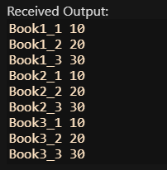
4 将一些无序的小数放入set，并从小到大顺序输出。
#include <iostream>
#include <set>
using namespace std;
int main() {
set<double> ist1;
for (int i = 1; i <= 10; i ++) {
ist1.insert(rand() % 50 * 1.1);
}
for (set<double>::iterator it = ist1.begin(); it != ist1.end(); ++ it) cout << *it << " ";
cout << '\n';
set<double> ist2;
for (int i = 1; i <= 10; i ++) {
ist2.insert(rand() % 50 * 1.1);
}
for (set<double>::iterator it = ist2.begin(); it != ist2.end(); ++ it) cout << *it << " ";
cout << '\n';
set<double> ist3;
for (int i = 1; i <= 10; i ++) {
ist3.insert(rand() % 50 * 1.1);
}
for (set<double>::iterator it = ist3.begin(); it != ist3.end(); ++ it) cout << *it << " ";
cout << '\n';
return 0;
}
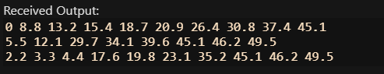
5 使用map，按学号，依次输出学生姓名和成绩。
#include <iostream>
#include <string>
#include <map>
using namespace std;
int main() {
map<string, pair<string, int>> imp1;
imp1["202105010001"] = {"Mike1", 80};
imp1["202105010042"] = {"Mike2", 65};
imp1["202105010056"] = {"Mike3", 32};
imp1["202105010015"] = {"Mike4", 92};
imp1["202105010080"] = {"Mike5", 65};
for (map<string, pair<string, int>>::iterator it = imp1.begin(); it != imp1.end(); ++ it) cout << (*it).first << " " << (*it).second.first << " " << (*it).second.second << '\n';
map<string, pair<string, int>> imp2;
imp2["74986532"] = {"fytghb", 80};
imp2["798489465132"] = {"e5yrhdfb", 65};
imp2["4896513"] = {"wefsdc", 32};
imp2["798465132"] = {"wefsdf", 92};
imp2["798465145689"] = {"Miqefke5", 65};
for (map<string, pair<string, int>>::iterator it = imp2.begin(); it != imp2.end(); ++ it) cout << (*it).first << " " << (*it).second.first << " " << (*it).second.second << '\n';
map<string, pair<string, int>> imp3;
imp3["7465132"] = {"wges", 80};
imp3["76835421"] = {"qefa", 65};
imp3["7834587354"] = {"qrefadc", 32};
imp3["734578345"] = {"y4wgrsd", 92};
imp3["783549635487654"] = {"46jhegrwefq", 65};
for (map<string, pair<string, int>>::iterator it = imp3.begin(); it != imp3.end(); ++ it) cout << (*it).first << " " << (*it).second.first << " " << (*it).second.second << '\n';
return 0;
}
6 使用mutlimap，存放书本信息（编号、书名、出版社、价格）。要求能插入、删除书本，查询某书本信息，统计已卖出的书本总金额等。
#include <iostream>
#include <string>
#include <map>
using namespace std;
int main() {
map<string, pair<string, int>> imp1;
imp1["202105010001"] = {"Mike1", 80};
imp1["202105010042"] = {"Mike2", 65};
imp1["202105010056"] = {"Mike3", 32};
imp1["202105010015"] = {"Mike4", 92};
imp1["202105010080"] = {"Mike5", 65};
for (map<string, pair<string, int>>::iterator it = imp1.begin(); it != imp1.end(); ++ it) cout << (*it).first << " " << (*it).second.first << " " << (*it).second.second << '\n';
map<string, pair<string, int>> imp2;
imp2["74986532"] = {"fytghb", 80};
imp2["798489465132"] = {"e5yrhdfb", 65};
imp2["4896513"] = {"wefsdc", 32};
imp2["798465132"] = {"wefsdf", 92};
imp2["798465145689"] = {"Miqefke5", 65};
for (map<string, pair<string, int>>::iterator it = imp2.begin(); it != imp2.end(); ++ it) cout << (*it).first << " " << (*it).second.first << " " << (*it).second.second << '\n';
map<string, pair<string, int>> imp3;
imp3["7465132"] = {"wges", 80};
imp3["76835421"] = {"qefa", 65};
imp3["7834587354"] = {"qrefadc", 32};
imp3["734578345"] = {"y4wgrsd", 92};
imp3["783549635487654"] = {"46jhegrwefq", 65};
for (map<string, pair<string, int>>::iterator it = imp3.begin(); it != imp3.end(); ++ it) cout << (*it).first << " " << (*it).second.first << " " << (*it).second.second << '\n';
return 0;
}
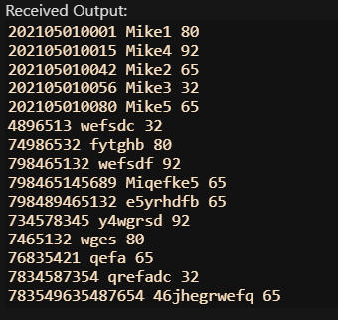
四 实验小结
巩固了C++的STL。

